**ASSA Abloy – 02/07/2021 Latest Situation**

**Outside Scope – Mani to advise options/costs etc:**

1. Last 5 CRM interactions to pull through when call comes in (#7 on AA spreadsheet)
2. Have a maximum of 5 tickets allocated via Round Robin with rest of e-mails waiting in an “Unassigned” queue. (#54 on AA spreadsheet). **They see this as critical.**

**General Items:**

1. Agent availability social channels – ie available to take chats but not e-mail. (#56 on AA spreadsheet)
2. Multiple Admin logins – Mani to confirm when switched on. Moved to Wed Day
3. Verdana font – everything for e-mail, responses, auto-replies etc. (#15 on AA spreadsheet) FIXED
4. Agent/Admin Manuals – **critical. Wed day**

**Phone Module:**

1. Call queue – call waiting includes calls in queue, 19 agents on phone the first person waiting to assign to an agent says your are 20th in queue. Megan had her tech test this but couldn’t replicate – Mani can you comment here from 3CX perspective? (#22 on AA spreadsheet) Please Raise a ticket in 3cx and let me know the ID
2. Attended transfer (#39 on AA spreadsheet) – being worked on – ETA? NO ETA
3. Transfer to conference another agent into call with customer (#51 on AA spreadsheet) NO ETA
4. Question 02/07 meeting – are phones in both phone and mobile fields recognized by Omni to display the caller?

**E-mail Module:**

1. Filter + select multiple filters (#31 on AA spreadsheet) – **they see this as critical. Out of scope but we will try to fix wed day** 
   1. 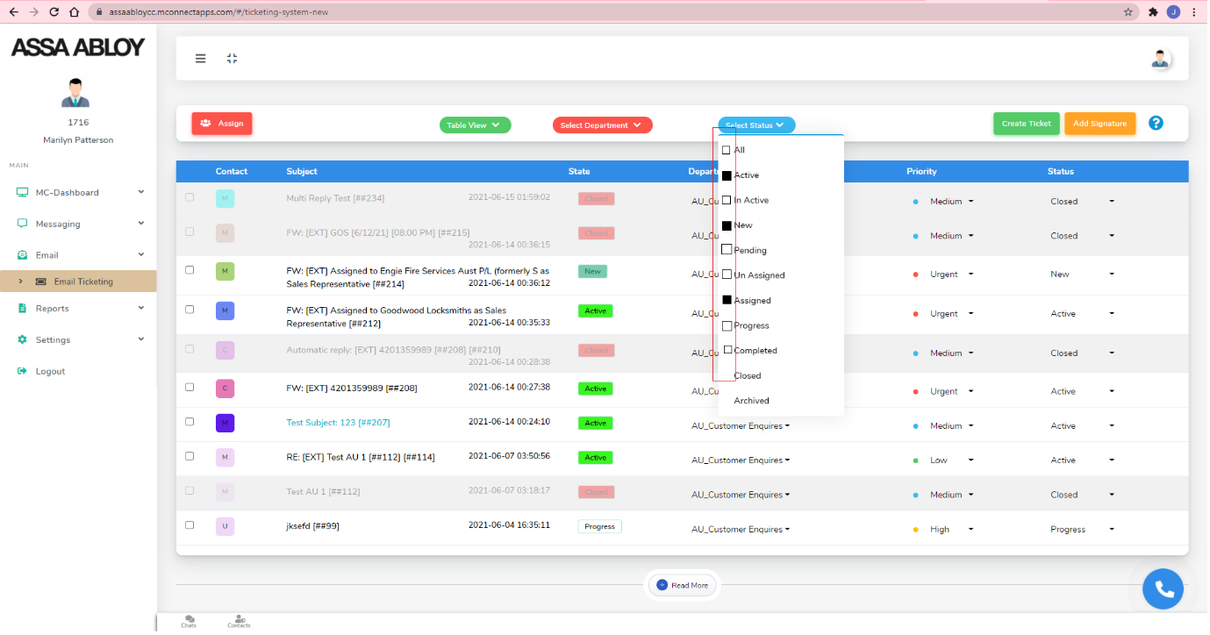

Not able to search by ticket ID #, subject or sender (#48 on AA spreadsheet) – this is important function to be able to use the e-mail ticketing. Not able to search by ticket ID #, subject or sender FIXED

1. Ability to edit existing e-mail signatures (#55 on AA spreadsheet) – due by Monday. FIXED
2. Agent is assigned an e-mail from the queue via Round Robin and wants to re-assign to a more suitable agent in the same queue – the option is greyed out. (#60 on AA spreadsheet). **What are the implications of allowing this please? FIXED**
3. Time stamp on e-mails says “Just now” everytime, needs to display the date and time received or sent. (#74 on AA spreadsheet). Raised on meeting 02/07. FIXED
4. Ticket templates – assign by queue. Out of Scope

**Chat Module:**

1. They require the ability to filter (see #’s of chats in each status) + select multiple filters similar to e-mail. (#32 on AA Spreadsheet). **Is this outside scope?**
2. Need to be able to send hyperlinks/images both ways – customer to agent and agent to customer. (#40 on AA spreadsheet). Image only deployed
3. When a customer selects the department on Chat, that department info needs to be available to the agent answering the chat. (#44 on AA spreadsheet). FIXED
4. If a Chat is closed by the customer with no agent response – AA want to be able to report on the customer name, e-mail, question, dept, website visited, chat opened time and chat closed time. (#46 on AA spreadsheet) FIXED
5. Please include the website page that the chat is started from as well as the department (#44 above). (#62 on AA spreadsheet) Already fixed in last update ?
6. Chats are not assigned to an agent, want a way to claim/distribute. Also ability to transfer to a more suitable agent. (#63 on AA spreadsheet) – **Is this outside scope?**
7. Display Name/Alias for the chat depts (#70 on AA spreadsheet) – in progress.
8. Offline – doesn’t display out of hours. Contact us link?
9. Comment about only “yes” typed that way works, can all options for how they type “YES” be added for the transfer from ChatBot to Chat? - Fixed  however ‘YES’ , ‘Yes’ , ‘YEs’ do not work , it works only with  ‘yes’ - FIXED

**Facebook Module:**

1. Agent name – not yet fixed. FIXED
2. More discussion around the flow required here.

**Wallboard/Reporting: (Out of Scope)**

1. Require wallboard to encompass OmniChannel space not just calls. Represent all queues. (#41 on AA spreadsheet).
2. E-mail reports: I cannot seem to locate reports related to emails. (#57 on AA spreadsheet)
   1. For example
      1. Queue Stats
         1. Time in Queue before Assigned
         2. Average Time taken to close
         3. Count Reassigned
      2. Agent Stats:
         1. Time taken to close
         2. Time taken to 1st Response
         3. Count Closed in a period
         4. Count reassigned
3. Chat Reports: cannot seem to locate reports related to relating to Chat and other Messaging (#58 on AA spreadsheet).
   1. For example
      1. Queue Stats
         1. Time in Queue before Assigned
         2. Average Time taken to close
         3. Count Reassigned
      2. Agent Stats:
         1. Time taken to close
         2. Time taken to 1st Response
         3. Count Closed in a period
         4. Count reassigned
4. Chat Ratings report should include the agent assigned to the chat. (#64 on AA spreadsheet)
5. In regard to User Story 45 - As a Ops Lead, I want to schedule reports to execute automatically, so reports are emailed to appropriate stakeholders. Unable to see functionality that supports automated reports? (#65 on AA spreadsheet). **Outside of scope – what is possible?**